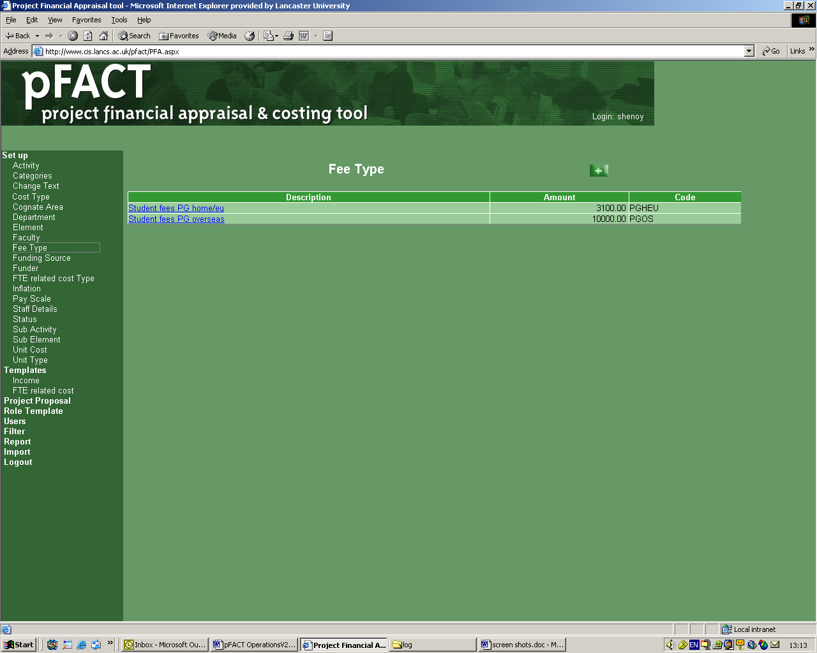

pFACT is the University’s research project costing tool and all externally funded research proposals must be costed on a full economic cost basis in accordance with TRAC guidance (see Annex I) and fully approved internally before submission.

**Access**

pFACT can be accessed via the URL <http://pfact.lancs.ac.uk/pfact>

A User ID and Password are required. If you have not already been issued with a User ID please contact the pFACT Helpdesk on ext. 92068 or [rso-submissions@lancaster.ac.uk](mailto:rso-submissions@lancaster.ac.uk)

The User ID will be the same as your allocated windows ID and the password will be allocated by the Research Support Office (RSO).

**IMPORTANT** – once you have received your account details you must log on and change your password.

You will be asked to agree to the Policy on Confidentiality and Data Protection Act Terms and Conditions each time you log on.

**Training**

The RSO generally provides one to one training on the use of pFACT and the costing and pricing of projects according to TRAC for any member of staff new to the costing procedure. However, if there are a number of new staff who would like a group training session this can be arranged. Please contact the RSO for details.

**Project View Permissions**

As a Principal Investigator (PI) you will be able to see any project where you are named as PI, as well as projects where you are included as a named member of staff. The information you can see in pFACT is determined by the user type which restricts the information in some of the staff drop down lists:

Principal Investigator – this drop-down list will only contain staff from your department

Co Investigator – this drop down list will contain staff from your faculty

Add staff to project - this drop down list will contain staff from your faculty

New unnamed staff required for the project can be added by clicking on the link Add staff not in list. New unnamed staff can be allocated to any department. It is important to indicate which department staff will be working in if this is different from the main department as a different estates cost may apply.

When completing work spells it is important to accurately estimate the amount of time to be spent on the project, especially for the academic staff involved.

**Note**: If you intend to prepare a cross-faculty proposal you will need to contact the RSO who will grant access to cross-faculty staff on a project-by-project basis.

###### Costs to include

The pFACT software has been designed to allow the full ***cost*** of a research project to be identified so this can be compared to the ***price*** (the income received from the funder).

The cost of a project will always be the same and may include elements that may not be deemed as eligible for funding by a particular funder, in which case these items would not be included in the price. When building up your project costs it is important to identify ***all*** the costs whether they are eligible for funding or not.

Estimating Staff costs

The time commitment of staff required to work on the project should be estimated using the most appropriate method. This may be either in hours per week, percentage time or total hours. pFACT will automatically calculate the cost of staff once their estimated time contribution is added to a project. Staff could include:-

* Academic staff time e.g. principal investigator and co-investigators. An estimate of the time commitment should include all the time required to undertake the project including report writing and supervision of the researchers but **not** supervision for research students.
* Other project staff (researchers, dedicated technicians and support staff etc)
* Laboratory pool technicians
* Project studentships (stipend and fees)

pFACT will automatically include a cost for technicians supporting infrastructure in laboratory-based departments.

**Note**: If a member of academic staff is being wholly funded from another research project or fellowship their cost should **not** be included. In some circumstances it may be appropriate to include their time commitment at a zero cost. Advice should be sought from a member of the RSO.

Time committed against externally funded research projects should not exceed 1650 hours per year. However, it is sufficient that the estimates for a group of academics working on cost-based projects (e.g. research councils) should not exceed 1650 hours per fte in a year.

Non-staff costs

The estimated costs for all non-staff elements required to undertake the project should be added. These may include:-

* Recruitment costs (all projects that employ new staff should include advertising costs)
* Equipment (including installation charges, maintenance, shipping costs and insurance)
* Travel and subsistence
* Consumables
* Disposal of waste (e.g. specialist disposal of chemicals)
* Software
* Training courses
* External fees

Of course, this is *not* an exhaustive list and the costs included will depend on the research being undertaken.

###### Removal of Data

Costs can be removed at any time whist the project status is ‘draft’ by using the remove option. A pop up box will request a reason for removal. This is required for audit purposes and the number of staff added and removed from a proposal will be monitored.

**Indirect costs**

The FTE related costs are comprised of an indirect cost and an estates charge for the project. The FTE related costs for the project are calculated using the institutional rates and the FTE values of academic and research staff involved in the project.

**Funders**

The most frequent or recent research funders at Lancaster University have been included in the pFACT database.

Funding Source – the drop down list is grouped into the main funding sources.

Funder – the drop down list will show the funders classified under a particular funding source. If the funder you require is not listed please contact the RSO.

**Note:** For reporting reasons ***The Royal Society*** is included under UK Government and ***The British Academy*** is included under Research Councils.

###### Income Templates

Currently, there are a number of income templates built into the pFACT system each specifically set up to calculate the ***price*** of the research to different funders.

The templates include:

* 80% of fEC – for Research Council proposals from 1 September 2005 (80% of the full economic cost plus 100% of exceptions e.g. student stipends and fees).
* 100% fEC – for Government Departments
* Direct costs only – for UK Charities (no indirect costs, estates charge or academic costs included)
* EU FP7 – for European Commission Framework Programme 7 projects
* 100% fEC – for Industry or Commercial funders

If the funder you have identified does not have an obvious Income Template please contact the RSO for advice.

It is also possibleto build up the project costs before a funder is identified by picking funding source and funder ‘to be confirmed’. However, a project costing must have a funder allocated before it can be forwarded for approval.

**Recalculate**

Whenever data that affects the overall cost of a project has been amended pFACT will recalculate the project costs. However, it is good practice to use the ‘recalculate’ button to check all changes have been incorporated into the project costs before sending to your Department Approver.

**Approval Process**

Before sending the proposal for approval note the following: -

1. Use the ‘Notes’ button on Proposal Summary screen to add in a brief summary of the research to be undertaken. A section from the research proposal can be cut and pasted in.
2. It is mandatory to answer all the questions in the ‘Additional Fields’ (found at the bottom of the right-hand menu). The questions are grouped under ‘**Project Information**’ and ‘**Ethics Checklist**’
3. The final version of the submission e.g. funder’s proposal forms, case for support, should be forwarded to the RSO to allow validation against the information on pFACT. The HoD and Dean will also require this information.

Once the financial details are finalised and the pFACT proposal is complete and ready to be approved for submission, use the STATUS button to change the status from Draft to Pending HOD Approval as follows:-

Click on ‘**change status**’ button (on right hand side of screen)

Click on ‘🞤‘ button

The ‘change status’ window will appear.

Complete the details on screen as follows:

Status from/status to: leave as default

Priority: as appropriate (this would normally be Medium)

Date of change: the current date (can be selected from calendar)

Target date: as appropriate (the deadline for submission appears at the bottom of the e-mail notifying the Head of Department that the proposal is awaiting approval).

Submitted to: select the appropriate department approver e.g. ‘**\* ES Approver**’

Notes: Further notes can be added here for the approver’s attention if appropriate

Click on ‘**save**’ button, the proposal is now ready for first level approval and you will be taken to the e-mail notification screen.

By default the software will e-mail the PI, department approver and RSO, so you will see their names on the list. Additional people can be added to this list, if required. (You may also see tick boxes with no name next to them; these can be ignored.)

Click on ‘**send**’ button (IT IS IMPORTANT TO CLICK ON SEND BEFORE CLOSING, OTHERWISE NO-ONE WILL RECEIVE NOTIFICATION THAT THE PROPOSAL REQUIRES APPROVAL)

The dialogue box can now be closed

It is important to indicate the deadline date for submission to the funder on your project summary and to allow sufficient time once you have completed your proposal for it to go through the approval process. The table below is provided as a guide.

|  |  |
| --- | --- |
| **Approval Stage** | No. of days required |
| Proposal sent to HoD for approval | Allow up to 2 working days for approval |
| Proposal sent to Dean for approval (with effect from 1 August 2005) | Allow 3 working days for approval |
| Proposal approved and forwarded to RSO for validation and Approval. *This should include the final version of the case for support or funder’s proposal forms.* | Allow up to 2 working days for validation by RSO |
| Signature/approval by a Delegated Authority | Allow 3 working days for approval and signature (if required) by a Delegated Authority |
| Total number of days required for approval prior to submission deadline: | 10 working days (max.) |

**Note**: If sufficient time is not allowed for this process, the submission of a proposal within the deadline may be jeopardised.

If the value of the proposal is likely to exceed £250K please advise the RSO as soon as possible so that arrangements can be made for signature by the relevant Delegated Authority.

RSO Helpdesk

Email: [rso-submissions@lancs.ac.uk](mailto:rso-submissions@lancs.ac.uk)

Ext. 92068

**Annex I.**

**Transparent Approach to Costing (TRAC) fEC: the forecasting and accounting for full economic costs at a project level.**

From 2005 all HEIs are required to calculate the fEC of each research project on a reliable and comprehensive basis. This cost is then used to set the price for grant made by Research Councils and Government Departments and informs the price of projects to other funders.

HEIs applying for future research grants now have to identify the fEC of a project. Funding from Research Councils is 80% of the fEC and Government Departments should fund 100% of fEC. Identifying the fEC of a project with help institutions to avoid inadvertently subsidising work, which should at least be at ‘full economic cost’ for example, funding for commercial work for industry. Institutions need to plan to make surpluses on their commercial or contract research work, as part of their balanced portfolio. It has never been allowable to subsidise such work from public funds, but institutions have been reminded of these responsibilities through the Financial Memorandum under which they operate with the Funding Councils.

If the funding is less than 100% of fEC, the institution has to be aware of its own financial contribution and to ensure wither that it has sufficient public funding to subsidise ‘scientific public good ‘ research; or that the research project is of sufficient strategic interest to justify subsidy through any other funds that it has available. HEIs do not have to account publicly, at a project level for these subsidies, but they should be able to reassure themselves that across their portfolio of activities, taking one year with another, they have the funds available.

**Calculation of the full economic cost**

The fEC of a project is made up of directly incurred costs, directly allocated costs and indirect costs. The classification determines how they are recorded and validated.

**Directly incurred (DI)**

These included researcher costs, consumables, travel, equipment etc. and are recorded on the basis of actual expenditure. The DI costs need to be recorded and accounted for in an auditable manner i.e. for staff working less than 100% time on any Research Council funded project this will involve the completion of timesheets. Virement may be allowed between categories of directly incurred costs depending on the funder.

**Directly allocated (DA)**

These include academic costs, some technician or support costs, some facility charges and estates costs. DA costs are charged to projects on the basis of standard costs established at the time of project approval and do not change throughout the project (unless there is a significant change to the programme of work). Virement of directly allocated costs is not allowed.

Principal investigators are not formally required to account for their actual time spent on projects. However, they should be in a position to confirm broadly that the time estimated at the start of the project has been spent on the project and they should be able to provide other evidence of time spent such as paper-based diary entries, records of meetings, laboratory notebooks etc. Similarly, there is no need to monitor actual use of estates and other directly allocated costs.

**Indirect costs**

Indirect costs are charged to projects on the basis of standard costs established at the time of project approval and do not change throughout the project (unless there is a significant change to the programme of work). Virement of indirect costs is not allowed.

Both indirect and estates costs are calculated on the basis of an institutional rate x full time equivalent (fte) of the researcher and academic per project per year. For example: -

Research – 1.0 fte for 12 months

Academic – 0.1 fte for 12 months

Total project fte = 1.1 for 1 year

Indirect rate for HEI - £25000 x 1.1 fte = £27500 charge to project

Estates charge for HEI - £5000 x 1.1 fte = £5500 charge to project

The full TRAC guidance can be found here - <http://www.jcpsg.ac.uk/guidance/>